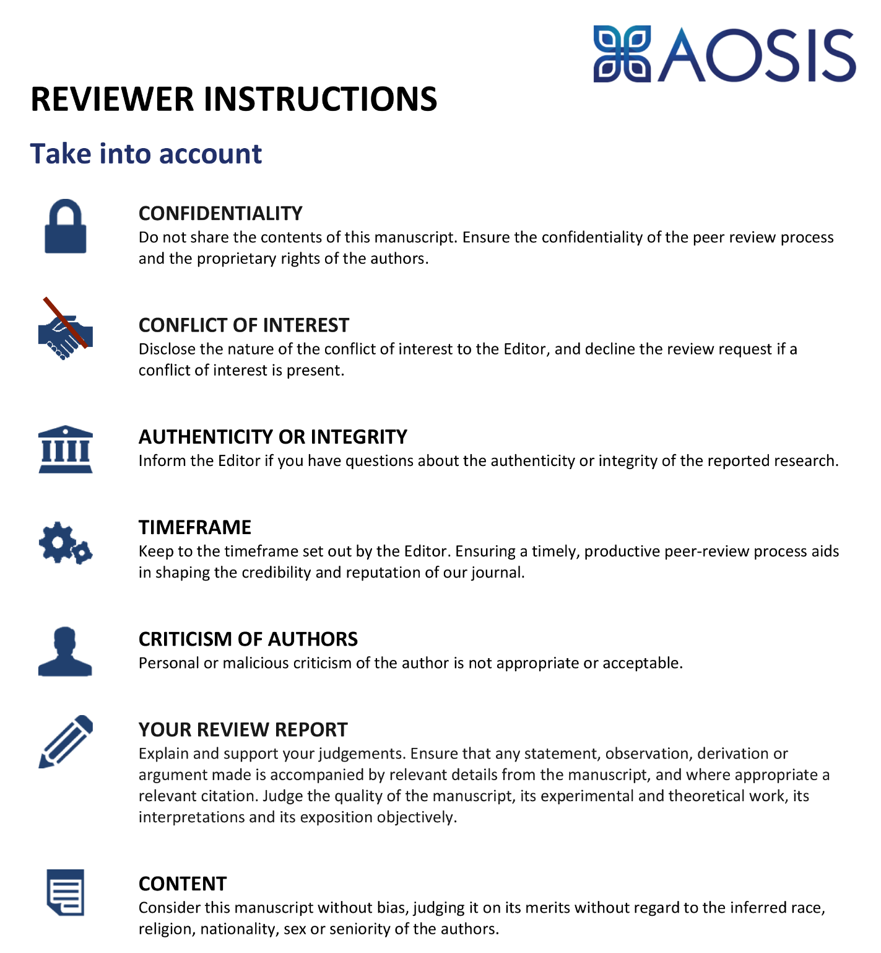

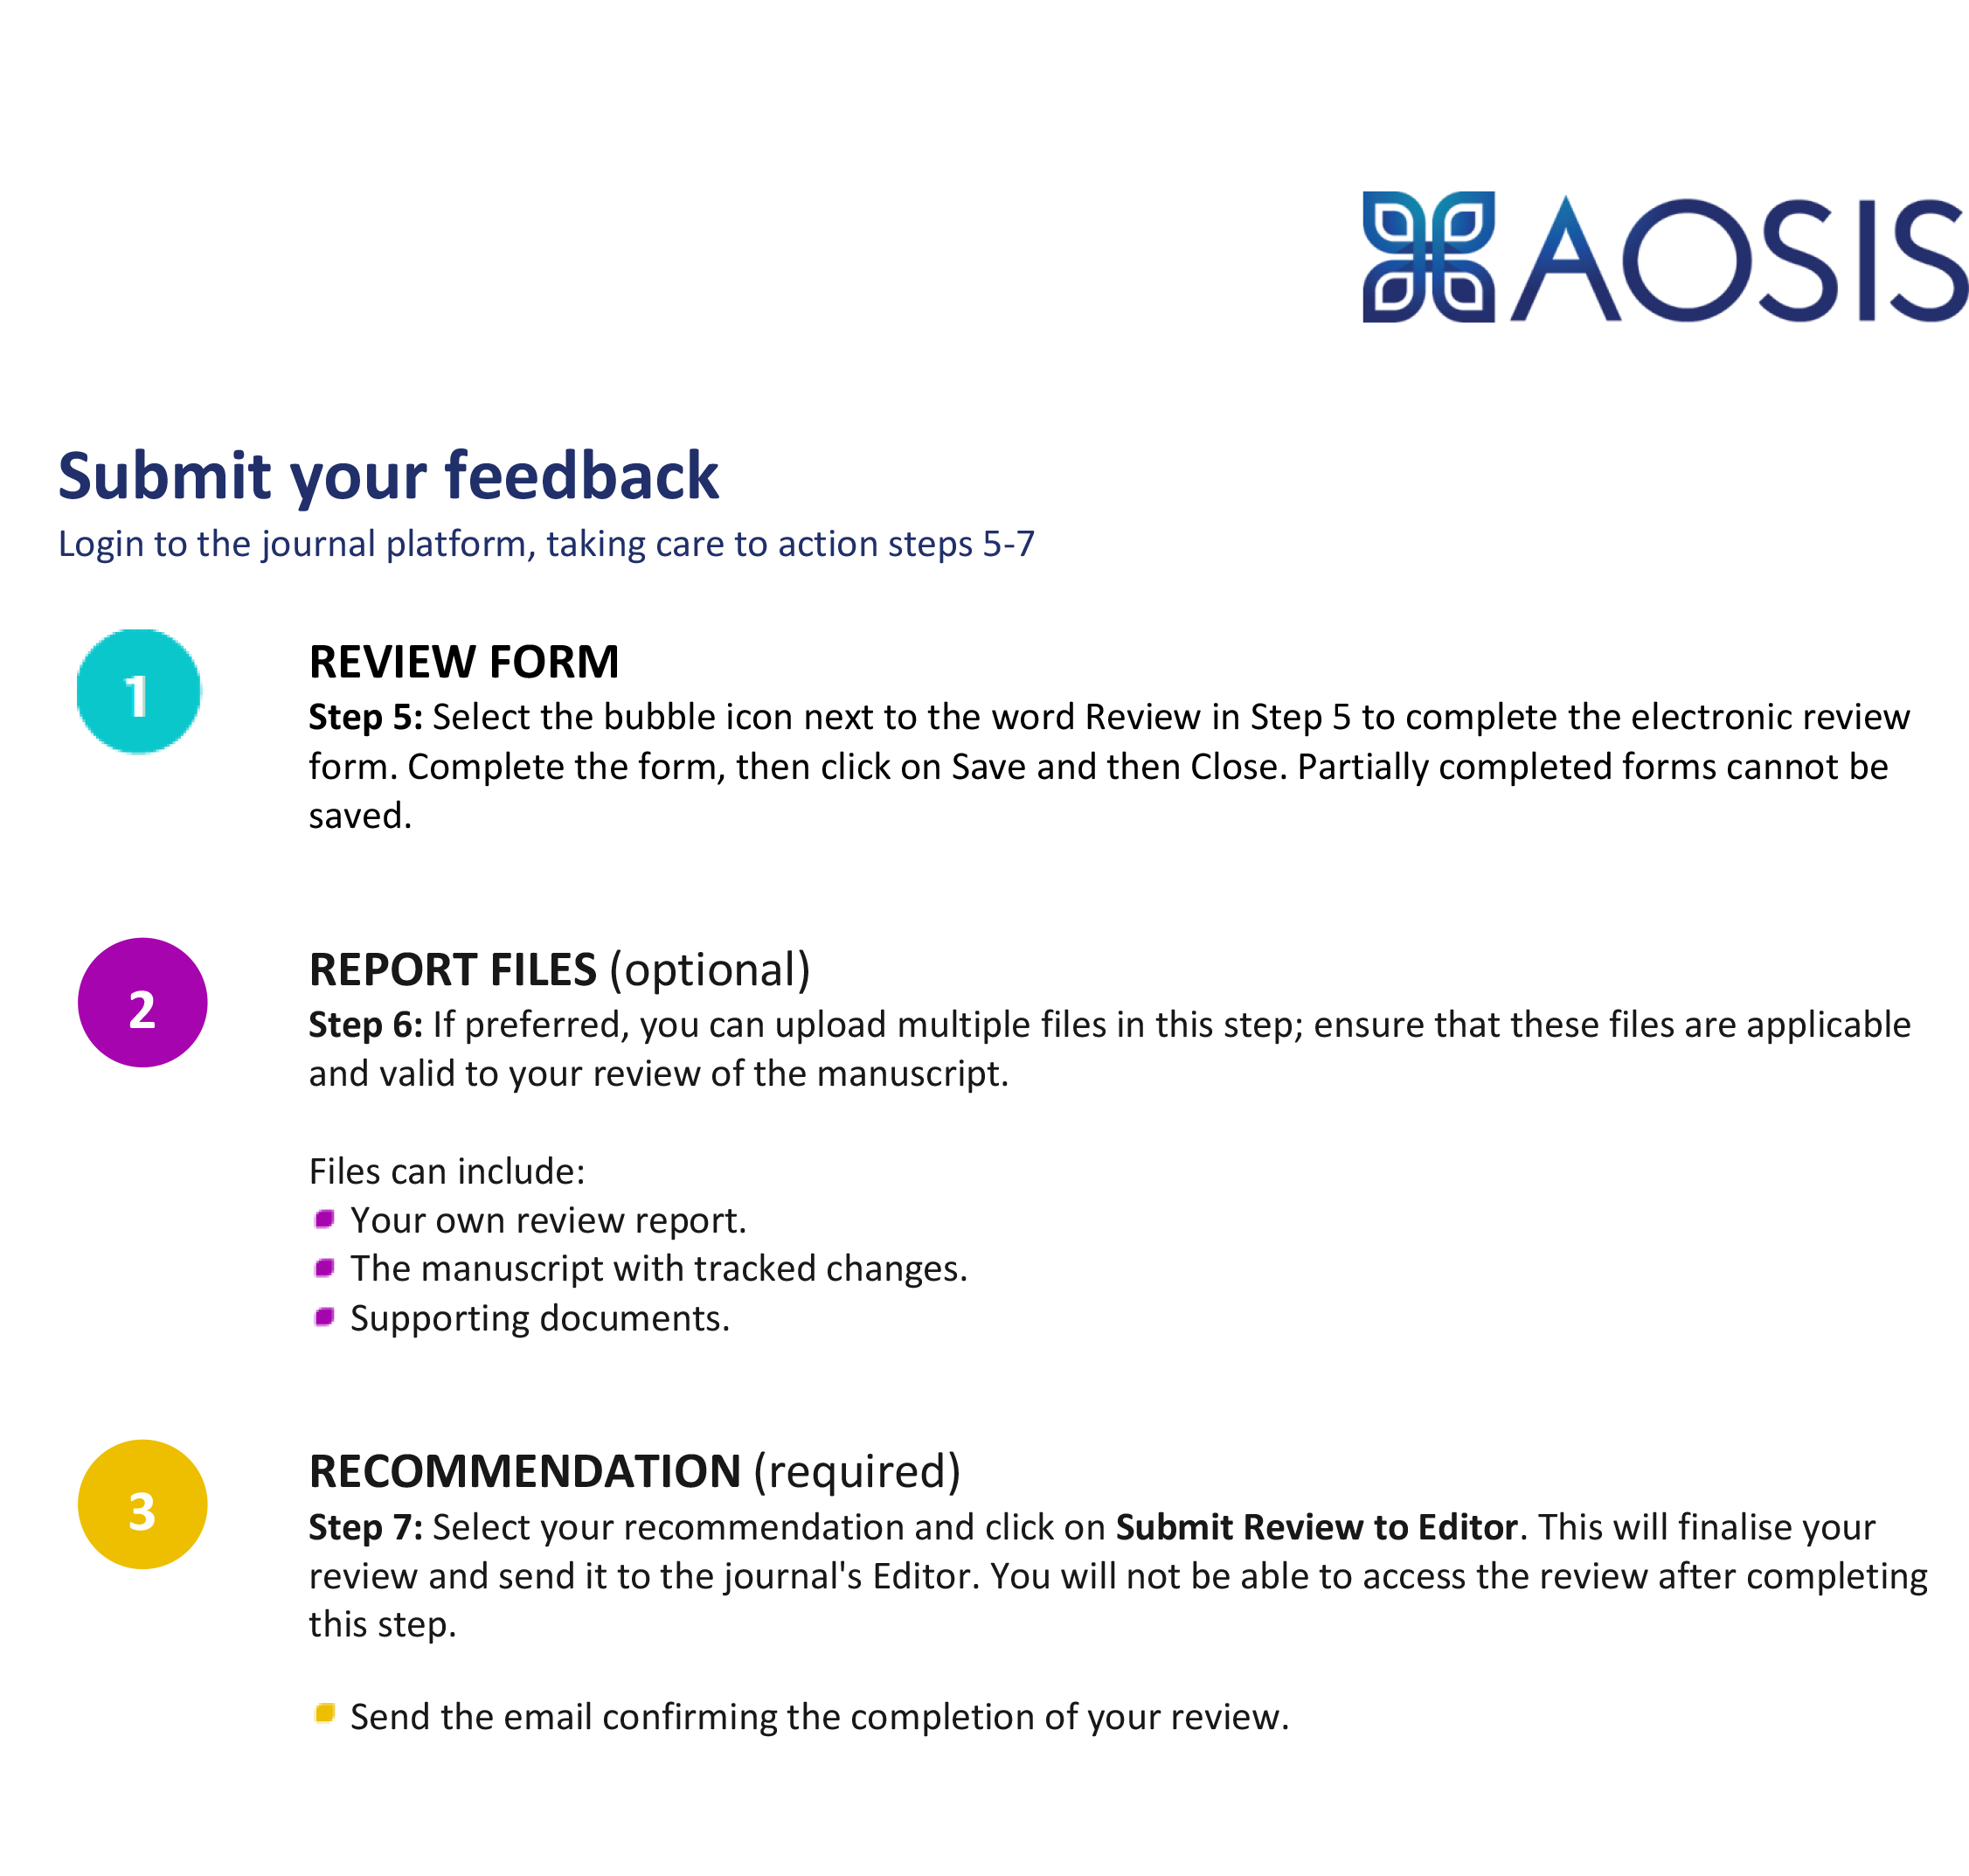
MANUSCRIPT TO REVIEW

Exploring the Need for Using Digital Storytelling based on Local Wisdom (DSLW) to Improve Writing Skills Elementary School Students: Teacher Perception

Teachers' Perceptions on the Need to Use Digital Storytelling Based on Local Wisdom to Improve Writing Skills
[Information redacted to maintain the integrity of the review process]

Abstract:
Background: Local wisdom-based digital storytelling emerges from a combination of storytelling and digital integration with local wisdom to meet the needs of teaching materials in elementary schools, such as communication and self-expression, as well as to facilitate learning in improving language skills, one of which is in the aspect of writing skills.
Aim: The purpose of this research is to find out the needs of teachers in using digital storytelling based on local wisdom.
Setting: This research begins with a survey of several elementary schools in Pandeglang to explore the extent to which digital storytelling is based on local wisdom selected by purposive sampling.
Method: Data was collected through questionnaires to 60 teachers and semi-structured interviews with 24 teacher participants to validate the results and develop a deeper understanding.
Result: This research can also be a reference and input for educators, especially elementary school teachers, in innovating in developing teaching materials to create an active and fun learning process for elementary school students to achieve learning objectives.
The development of digital storytelling teaching materials based on local wisdom needs to pay attention to the principle of meaningfulness; the principle of authenticity; The principle of integration and the principle of functioning, then the principle of communicative performance, contextual principles, and the principle of assessing conditions delivered by teachers. Based on the results of the study, most teachers' perceptions agree on developing digital storytelling teaching materials based on local wisdom to improve the story writing skills of elementary school students.
Conclusion: In conclusion, digital storytelling teaching materials based on local wisdom can be developed and applied in the teaching and learning process.
Contribution: This research can also be a reference and input for educators, especially elementary school teachers, in innovating to develop teaching materials to create an active and enjoyable learning process for elementary school students to achieve learning objectives.

Keywords: Digital storytelling, Local Wisdom, Writing Skills.
Introduction

Indonesian language learning, carried out in accordance with the achievement orientation of the learning objectives, will encourage students to become proficient in Indonesian. Students trained in Indonesian will find it easier and faster to learn and can achieve achievements. Learning Indonesian, oriented toward achieving language learning objectives, can hone their reasoning and train students to practice thinking coherently, orderly, and thoroughly. For elementary school students, it will be easier to reconstruct their memories of events or experiences through stimulation. One of the stimulations that can be used to improve memory related to language competence is telling stories using digital storytelling teaching materials based on local wisdom in classroom learning. (Lee, 2014 and Robin, 2016).
The learning program is not just a series of topics/topics, but an issue that students must understand and master and can use in their lives. Basic education in Japan shows that previous conceptions about something students have based on character and cultural background are important in the learning process. Students of all ages have concepts about various phenomena they bring to class (Widisuseno, 2019). The initial ideas these students possess can be sourced, among others, from cultural backgrounds, family, media, and other things. Students directly hear, see, experience, and, at the same time, use it. This concept proved to be very helpful and valuable in the context of his life, likewise with students' writing abilities. The right strategy will encourage writing skills to develop by learning objectives.
Writing is one of the most complex cognitive activities and involves many cognitive components (Olive, 2004). Individuals find the thoughts and ideas they want to express in their stories through the writing process (Miller, 2010). With digital storytelling, students can learn the art of writing good stories, how text and art can be integrated, and how technology can be used creatively (Miller, 2010). In addition, when students fully engage in the writing process, they compose stories and participate more effectively in the digital story creation process by developing good scenarios (Xu et al., 2011). Previous research has shown that digital storytelling develops students' writing skills and can be used as an effective learning tool, especially in computer-assisted language acquisition (Abdollahpour, 2018).
Changes in the learning paradigm during the pandemic in schools, especially elementary schools, have made fundamental changes in terms of objectives, processes, and learning outcomes. Limitations and even prohibitions for face-to-face learning force teachers to strive to create safe learning according to students' needs. So digitalization in learning is a must. Based on observations in the field during both offline and online learning periods, researchers found that the learning process was still conventional; most teachers used books as the main medium that was often used in learning. Even though currently the implementation of education in the world has undergone drastic changes, previously face-to-face learning is now hybrid learning (Ololube, 2014), blended learning (Fong, 2007), flipped learning (Casselman, MD, Atit, K., Henbest, G., Guregyan, C., Mortezaei, K., & Eichler, 2020) has a significant impact on learning but demands digital skills and literacy for teachers and students (Grimaldi, E., & Ball, 2019). This research is motivated by the current educational situation that requires technology-based learning innovations in elementary schools. One of them is by developing digital teaching materials.
The statement above aligns with the research results (Pujilestari, 2020) regarding using information technology as a keyword in online learning to enable students to learn better, faster, and smarter. Another term is known as ICT (Information and Communication Technology). UNESCO revealed that several benefits could be obtained by implementing information and communication technology in the education system, namely facilitating and expanding access to educational networks, increasing educational equity, learning quality, teacher professionalism, and more effective and efficient management and governance of education (Adisel, Gawdy, 2020). People who are digital and information technology literate can be said to have adequate information and communication technology literacy (Tesi Muskania & Wilujeng, 2017). Teachers implementing online and offline learning must also have sufficient information and communication technology literacy to facilitate learning. Teachers need special training to improve their competence in information and communication technology (König et al., 2020).
Digital storytelling emerges from digital integration and storytelling to meet learning needs, such as communication and self-expression, and to facilitate teaching in improving language skills, one aspect of story writing skills. The results of previous research indicate that digital storytelling is effective in developing cognitive structures, which, initially, the development process of cognitive structures is believed to develop over a long period. Therefore, this study reveals the contribution of digital storytelling to the development of visual memory, which positively impacts the development and acquisition of information and abilities acquired during the learning process (Sarica & Usluel, 2016).
Other research shows that digital storytelling in learning can evoke positive responses to engaging learning, and the use of digital storytelling is recommended for continuous integration into the curriculum, which further supports effective learning (Yocom et al., 2020). Media digital storytelling shows that it can increase self-confidence and open-mindedness. Research subjects become more aware of power, alternative voices, and potential choices for them (Chan, 2019).
Interactive computer-based applications are said to be suitable for use in elementary schools. This is supported by research results showing that computer-based media play an important role as current learning media in the learning process. Computer-based applications are acceptable for use in learning because they can enhance the independent learning process and the active part of students (Rachmatullah et al., 2018). This shows the need to develop storytelling developed in elementary schools to meet the needs of the learning process. Furthermore, research that reviewed 57 literature reviews showed that the use of digital storytelling showed continued interest in elementary and middle school students and higher education. The use of digital storytelling is also often used in learning. This study recommends further research on digital storytelling for use in education (Wu & Chen, 2020).
Furthermore, it can be seen that moral messages and real pictures about everyday life will be able to stimulate the social spirit of students. In accordance with the learning objectives of improving the aspects of knowledge, attitudes, and skills of students, mediadigital storytelling this will play a role in creating all three aspects. Thus, the creation of the mediadigital storytelling for students is very important, not only playing a role in improving cognitive aspects, but also affective and psychomotor aspects of students as provisions for life in the future (Ratri, 2018).
Learning observers Lee (2014) and Robin (2016) stated thatdigital storytelling is an effective tool for students to improve their language skills. It is created by combining a number of digital media, such as sound, image and video components, with a duration of three to five minutes, and in some circumstances up to ten minutes (Stasiulis, 2019). Digital storytelling employs the use of media to present personal stories, as well as documentary recordings and stories that educate and put certain ideas or practices into practice (Robin, 2016). Furthermore, instructors have a variety of opportunities to engage and assist students through digital storytelling tools (Dreon, Kerper, & Landis, 2015).
According to Lee (2014), digitalstorytelling is one created by combining many digital media elements such as sound, images, and video. They are often made available free of charge via video services such as YouTube and other media video services that are increasingly easily accessible throughbrowser internet (Ohler, 2013), furthermore, Frazel (2011) said thatdigital storytelling is a method of combining several media to enrich and enhance the written or spoken word.
In line with some of the explanation aboutstorytelling above Fatih (2020) states thatdigital storytelling is defined as the creation of a short film using software to incorporate the multimedia artifacts provided by technology to a story or axis of events. The goal is twofold: to leverage storylines to make information much more effective and lasting, and to use technology to encourage students to become active participants in learning. "Writing initial scripts, developingstoryboard, discuss and refine the script, sequence images through the video editor, enter narrative text, add special effects and transitions, and add a soundtrack as time permits" are the seven phases of the process.digital storytelling.
Based on Yuliani's research, S. Hartanto, D. (2022) implements five videosstorytelling The digital Sakai tribe which has been used in English subjects with an online system. Studydigital storytelling has provided a variety of learning materials in English subjects. Based on the findings that the system requirementsonline digital Bringing new content, folklore and unusual sounds are appealing to students and teachers alike.
From the several opinions above, it can be concluded that the mediadigital storytelling is a media that utilizes digital images formed in innovative media in order to create learning methods that make it easier to understand learning as well as fun for students because they are in the form of real pictures in the surrounding environment and in accordance with the cultural background and social life of students.
The development of teaching materials is one of the obligations of teachers to become professional educators. One of the teaching materials includes learning media. Any learning media can send messages to stimulate students' thoughts, feelings, concerns, and interests in such a way that the learning process occurs. By its function, learning media is basically to improve the quality of teaching and learning. Therefore, in teaching and learning in schools, learning media has a very important role (Fahrurrozi et al., 2019). The development of learning media must pay attention to several things. The main principle of choosing instructional media is the effectiveness of teaching media in achieving learning objectives and helping students understand the material that will be presented. We must consider whether the learning media that will be used is more effective when compared to other media. Learning media must also be selected based on the principles of the level of student thinking (Ediyani, et.al., 2020). The third principle that must be considered in choosing media in classroom learning is interactivity and flexibility (Alexander, B., Adams Becker, S., & Cummins, 2016).
In this case, the researcher developed storytelling based on local wisdom in teaching materials designed to improve story-writing skills for elementary school students. The teaching materials chosen by the teacher for teaching and learning activities in the classroom must have good interactivity and flexibility. Teaching materials are said to have good flexibility if used in various situations. Thus, some of these things are used as a consideration for researchers to develop teaching materials in elementary schools. As knowledge and technology advance, teaching materials have been designed to suit various situations (Huang et al., 2019).
Teaching materials chosen by teachers for teaching and learning activities in the classroom must have good interactivity and flexibility. Teaching materials are said to have good flexibility if they can be used in a variety of situations. Thus, some of these things are used as considerations for researchers to develop teaching materials in elementary schools. As knowledge and technology advance, teaching materials have evolved to suit various situations (Huang et al., 2019).
Teaching materials are more effective if information can be seen, heard, and done. In this case, the researcher will develop language learning, especially aspects of writing stories for fourth-grade students in elementary schools (Munajah, et.al., 2021). The use of digital storytelling shows that in the learning process, children quickly understand and adapt the various mechanisms behind the system to create their stories, mostly involved in creating narratives or playing language games with levels. This research describes the application of digital manipulative techniques in an educational context, demonstrating that it is a useful tool that integrates into high-quality learning practices (Sylla et al., 2015).
There is an increase especially in abilities in the field of Information Technology, especially in the digital domain, namely making videos using certain software, the ability to work together in groups, and the ability to make presentations in addition to speaking skills and vocabulary mastery (Asri et al., 2017). Research (Bron & Barrio, 2019) shows that the existence of digital-based media that has been implemented in elementary schools is in the form of presentation slides, instructional videos, and animated videos. Digital storytelling is an interactive illustrated storytelling medium in the form of a combination of animated illustrated video, story text, and audio-visual so that learning will be more enjoyable and contextual (Anisimova, 2020).
The application of digital storytelling used by students makes students feel even happier and don't want to change lessons immediately. For this case study, the researcher included additional pictograms/pictures with vocabulary related to the cards used by the children. The idea is first to see if children know this vocabulary and if they don't, it is taught first by showing the corresponding word marks, then they are asked to associate each word with a specific story card (scene). From now on, the teacher begins teaching literacy from stories created by students and selected vocabulary based on the current knowledge and age of children's literacy (Flórez-Aristizábal et al., 2019).
The above shows why teachers' perceptual knowledge of local wisdom-based digital storytelling in learning is an important factor that will help implement local wisdom-based digital storytelling teaching materials in the education system effectively (Munajah, et.al., 2023). Perception is any process selection, organization and interplay of information input, sensation received through sight, feeling, hearing, smell and touch to generate meaning (Hasanah, et.al., 2023). The novelty of the research lies in the initial data for integrating local wisdom and digital storytelling that will be developed by researchers and
research following the current developments and technological needs in learning activities in elementary schools.
Therefore the researcher conducted a needs analysis study, which is important because further development research is carried out. The formulation of the problem in this study is as follows:
a. What is the teacher's perception of teaching materials commonly used in learning to write stories?
b. What is the teacher's perception of the need for innovation in developing teaching materials for learning to write stories?
c. What is the teacher's perception of the need to use local wisdom-based digital storytelling materials to improve story writing skills?
Therefore, the researcher conducted a needs analysis study, which is important because further development research is carried out. The formulation of the problem in this study is as follows: What is the teacher's perception of teaching materials commonly used in learning to write stories? What is the teacher's perception of the need for innovation in developing teaching materials for learning to write stories? What is the teacher's perception of the need to use local wisdom-based digital storytelling materials to improve story writing skills?

Methods

This research uses mixed methods by combining quantitative and qualitative data collection and data triangulation to go beyond the limitations of single-method studies by increasing credibility—teaching materials storytelling based on local wisdom in improving writing skills.
Research Design
They were collecting data on teacher perceptions about the need to use DSLW from the following four aspects (1) teacher perceptions of the suitability of teaching materials commonly used with teaching material selection criteria, (2) teacher perceptions about the need to develop digital storytelling teaching materials based on local wisdom to support Indonesian language learning, (3) the teacher's perception of the need to use digital storytelling teaching materials based on local wisdom to improve students' writing skills. The research was conducted in two stages; the first was giving questionnaires to 60 teachers. The second part conducted semi-structured interviews with ten teachers selected from a sample questionnaire. Ten teachers were interviewed about the same construct to gain a deeper understanding of the research constituents measured by the questionnaire.
The data collected in the form of quantitative analysis data from the needs on which the research is based are analyzed using percentage calculations. Qualitative data analysis was carried out by analyzing the results of interviews and field notes on teachers' perceptions of the development of teaching materials to improve writing skills.

Participants

First: the sample questionnaire consists of class teachers spread across Pandeglang. Questionnaires are available online so that teachers can easily access them anywhere to fill them out. This research was conducted in January 2021, in Indonesia still experiencing the Covid-19 pandemic. A total of 60 teachers who returned the completed questionnaire were considered the study sample. Given the physical distancing policy during this pandemic, a purposive sampling technique was used by distributing online questionnaires using Google Forms. Descriptive data on demographic characteristics, which include gender, length of teaching experience, educational background, and teacher education level, are presented in Table 1.
Table 1
Participant's Characteristic (n=60)

Aspek | Frequency | %
Gender
Female | 48 | 80
Male | 12 | 20
Working years as a teacher
1-5 years | 5 | 8.33
5-10 years | 34 | 56.67
10-15 years | 21 | 35
Educational background
Primary Teacher Education | 57 | 95
Others | 3 | 5
Level of education
Bachelor's | 59 | 98.33
Master's | 0 | 0
Others | 1 | 1.67

Findings

Data from questionnaires and interviews were obtained based on the perceptions of 60 elementary school teachers in the Pandeglang district. The suitability of the criteria begins with the results of the teacher's perception of the teaching materials that are often used with the suitability of the requirements for selecting teaching materials. Then to make the data more comprehensive, interviews were then conducted as a follow-up to obtain data about the need for innovation in selecting teaching materials for writing stories and how teachers perceive the need to use digital storytelling teaching materials based on local wisdom to improve story writing skills in elementary schools.

Research method

The use of a mixed method using two methods: questionnaires and semi-structured interviews with elementary school teachers in this research activity is prioritized to obtain data on the results of respondents and the results of the answers of the subjects so that it will facilitate data triangulation accuracy in validating and also in efforts to strengthen the data from the initial findings in the questionnaire activity. Then also to enrich the data in additional dimensions, as well as help facilitate and correlate research answers from different and more focused angles to answer the research problem formulation.
The data collected in the form of quantitative analysis data from the needs on which the research is based are analyzed using percentage calculations. Qualitative data analysis was carried out by analyzing the results of interviews and field notes on teachers' perceptions of the development of teaching materials to improve writing skills.

Questionnaire

Based on the results of the literature study and field observations, the researcher compiled a questionnaire to obtain information on a representative basis through the suitability of teaching materials commonly used with the criteria for selecting teaching materials; the suitability of the research questions evidenced this. The questionnaire has been designed based on a Likert scale. This questionnaire related to the principle of meaningfulness; the doctrine of authenticity; principles of cohesiveness and functioning principles, then communicative performance principles, contextual principles, and assessment principles.

Semi-structured interviews

Then in the second part, through open and semi-structured interviews discussing the need for innovation in the development of Indonesian language teaching materials in elementary schools, the third part examines teachers' perceptions of using digital storytelling teaching materials based on local wisdom. This activity is carried out to increase the validity and validity of data collection data.

Procedures

In this activity, before distributing the questions, the questionnaire was tested first for its validity and reliability. Its validity is checked through the degree of accuracy and the accuracy of the questions so that the research results are by the theoretical reasons and empirical facts about the suitability of the criteria or principles of selecting teaching materials, both in terms of content, construction and requirements. It was found that the general validity of the three components reached 0.52 – 0.64, recorded in the moderate category so that the questionnaire questions could be distributed to 60 elementary school teachers in the Pandeglang district. The reliability level has also reached 0.66, based on the index The Gregory questionnaire that has been prepared is appropriate for distribution to the respondent teachers because it has compared the moderate category. Thus the "DSLW" instrument for digital storytellingly based on local wisdom to teachers before it can be continued.

Results

The research results were obtained from questionnaires and interviews, which described present key research findings from quantitative and qualitative research data. These findings are very helpful in determining the implementation of local wisdom-based digital storytelling learning.
Quantitative Analysis
Based on the results of an analysis of the answers of 60 respondents, it was found that there are interesting things in conformity with the 60 principles. The results of the questionnaire are shown in the table below.
Table 2 Questionnaire Results

Based on the data above, it is obtained the result that the rate of not conforming is still high, especially at the criteria for applying contextual principles; reaching 95% not appropriate, then its authenticity going 25% is not suitable, meaningfulness is still 30% not right, and the direction of functioning up to 40%. This shows that efforts are still needed to adjust teaching materials used in schools.

Qualitative Analysis

To obtain comprehensive data, the results of the questionnaire data were then strengthened by conducting semi-structured interviews with a target of 24 people randomly representing each school in the Pandeglang sub-district. Based on the results of interviews with elementary school teachers, it can be obtained that the types of Indonesian teaching materials currently used are predominantly student worksheets. Then, in conformity with the principle of meaningfulness, most teachers perceive that there are still few teaching materials that encourage students to train independently to express the right thoughts, ideas, ideas, and information to others. Furthermore, in the aspect of the principle of authenticity, the teachers perceive that the teaching materials that have been used have not been able to meet the needs of children in communicating. Then in the aspect of integrating the required learning material, the material is conveyed as a whole, not partial, so that it helps children communicate. Then the teacher's perception of the working principle of teaching materials still needs to encourage children's creativity in language acquisition. In terms of the direction of Communicative Performance, teaching materials, according to the teacher, need to provide experiences - experiences that are comprehensive and meaningful in everyday life. On the principle that the teacher's perception shows that teaching materials are not contextually appropriate, teaching materials need to be prepared and adapted to students' cultural backgrounds, learning readiness, children's interests, and also student learning styles so that children can speak properly and correctly according to the context. In the principal aspect of assessment, it is obtained from the teacher's perception that review in teaching materials is to measure students' competence as a whole, especially in language skills in communicating, not just theory or grammatical aspects. So as a whole, all teachers think that there is a need for innovative Indonesian language teaching materials for elementary schools and can choose digital-based teaching materials.
This is in line with the results of research by Harjono, et al., (2022) the learning process assisted by video learning models can improve students' creative thinking skills, the creative thinking aspect in this study is in line with students' creativity in story writing activities. Furthermore, according to Sumantri et al., (2021) the use of technology in current learning can support the effectiveness of learning, with the use of technology that is currently developing in a positive direction, of course it can minimize the negative impact of the rapid development of technology. This statement certainly supports research to develop teaching materials digital storytelling based on local wisdom. Teaching materials digital storytelling which also includes learning video media, in line with the opinion of Heinich, Molenda, et al., (2001) and Edgar Dale (1969) who argue that learning interactions will be successful if using the right learning media, according to the needs and learning objectives of one of the learning media that can be used is digital media in the form of learning videos, audio-visual, and animation. This statement is also in line with Lee (2014), digital storytelling is one that is created by combining many digital media elements such as sound, images, and videos to aid the learning process. Learning videos are often provided free of charge through video services such as youtube and other video media services that are increasingly accessible via browser internet (Ohler, 2013), then, Frazel (2011) says that digital storytelling is a method of combining several media to enrich and enhance the written or spoken word. So develop teaching materials digital storytelling willvery useful in elementary schools to improve writing skills in particular and of course it can also be used for other aspects of language skills in students in elementary schools.

Conclusion

Based on the research findings and discussion, most teachers' perceptions agree that they should immediately develop local wisdom-based digital storytelling materials to improve elementary school students' story-writing skills. This result is supported by several statements (1) the principle of meaningfulness is still a bit of teaching material which encourages students to train independently to be able to express thoughts, ideas, ideas and appropriate information to others, (2) the principle of authenticity of teaching materials in order to meet children's needs in communicating, (3) the aspect of integration of the required learning material is the material delivered in its entirety not partial, (4) the principle of the functioning of teaching materials needs to encourage children's creativity in language acquisition, (5) In terms of the principle of Communicative Performance teaching materials need to provide a rich experience comprehensive and meaningful and everyday life, (6) Contextual Principles the teacher perceives that teaching materials are prepared and adapted to students' cultural backgrounds, learning readiness, children's interests and also student learning styles, so that children can speak properly and correctly according to the context, (7) The principle of assessment in teaching materials in order to measure competence The understanding of students as a whole, especially in language skills in communicating, is not just the grammatical aspect of samata. The results of this study are the first step of the next research, namely the development of teaching materials. This needs analysis can be used as an overview of the conditions of Indonesian language learning in elementary schools. It can be used as a reference for future researchers who wish to develop appropriate teaching materials for elementary school students.

Limitations and Suggestions for Future Research

This study used a survey to explore teacher perceptions and experiences while teaching students Indonesian language learning, especially in story writing skills. As with all research, this study has limitations. This research is a small representation of elementary school teachers who experience online and offline learning models in the Pandeglang City area. For this reason, future research will become more comprehensive and require quantitative or mixed methods studies with a wider sample. Future research can discuss the development of teaching materials that can be used in online and offline learning. This research can also be used as preliminary research for developing models and teaching materials for learning Indonesian appropriate for elementary school students from various backgrounds.
Acknowledgement
[Information redacted to maintain the integrity of the review process]

Competing interest
[Information redacted to maintain the integrity of the review process]

Author contributions
[Information redacted to maintain the integrity of the review process]

Funding
[Information redacted to maintain the integrity of the review process]

Data availability
[Information redacted to maintain the integrity of the review process]

Disclaimer
[Information redacted to maintain the integrity of the review process]
References

Abdollahpour, Z. (2018). The impact of exposure to digital flash stories on Iranian EFL learners' written reproduction of short stories. August.
Adisel, Gawdy, A. P. (2020). Penggunaan Teknologi Informasi dan Komunikasi dalam Sistem Manajemen Pembelajaran pada masa Pandemi Covid 19. ALIGNMENT : Journal of Administration and Educational Management, 3(1), 1–10. https://journal.ipm2kpe.or.id/index.php/ALIGNMENT/article/v. https://www.bing.com/search?q=Adisel%2C+Gawdy%2C+A.+P.+%282020%29.+Penggunaan+Teknologi+Informasi+dan+Komunikasi+dalam+Sistem+Manajemen+Pembelajaran+pada+masa+Pandemi+Covid+19.+ALIGNMENT %3A+Journal+of+Administration+and+Educational+Management%2C+3%281%29
Arrows, F., Cajete, G., & Lee, J. (2010). Critical Neurophilosophy & Indigenous Wisdom. In Sense Publishers. Sense Publishers. https://doi.org/10.1017/s0033291700037995
Alexander, B., Adams Becker, S., & Cummins, M. (2016). Living with New Technologies. Scientific American, 273(3), 190–205. https://doi.org/10.1038/scientificamerican0995-190
Anisimova, E. S. (2020). Digital literacy of future preschool teachers. Journal of Social Studies Education Research, 11(1), 230–253.
Babalola, J. . (2004). Management of Primary and Secondary Education in Nigeria. NAEP Publication.
Borg, W R & Gall, M D. (2003). Educational Research: an Introduction (7. ed). New York: Logman Inc.
Branch, R. M. (2009). Instructional design: The ADDIE approach (Vol. 722). Springer Science & Business Media.
Bron, M., & Barrio, M. G. (2019). Project-Based Learning for Teaching Transmedia Communication. Journal of Problem-Based Learning in Higher Education, 7(1), 141–151. https://doi.org/10.5278/ojs.jpblhe.v7i1.2405
Casselman, M. D., Atit, K., Henbest, G., Guregyan, C., Mortezaei, K., & Eichler, J. F. (2020). Dissecting the Flipped Classroom: Using a Randomized Controlled Trial Experiment to Determine When Student Learning Occurs. Journal of Chemical Education, 97(1).https://www.bing.com/search?q=Casselman%2C+M.+D.%2C+Atit%2C+K.%2C+Henbest%2C+G.%2C+Guregyan%2C+C.%2C+Mortezaei%2C+K.%2C+%26+Eichler%2C+J.+F.+%282020%29.+Dissecting+the+Flipped+Classroom%3A+Using+a+Randomized+Controlled+Trial+Experiment+to+Determine+When+S
Chan, C. (2019). Using digital storytelling to facilitate critical thinking disposition in youth civic engagement: A randomized control trial. Children and Youth Services Review, 107, 104522. https://doi.org/10.1016/j.childyouth.2019.104522
Chen, D., Liu, Z., Luo, Z., Webber, M., & Chen, J. (2016). Bibliometric and visualized analysis of energy research. Ecological Engineering, 90, 285–293. https://doi.org/10.1016/j.ecoleng.2016.01.026
Cororaton, C. B. (1999). R&D Gaps in the Philippines (No. 1999-16). PIDS Discussion Paper Series.
Dale, E. (1969). Audio-visual methods in teaching (3rd ed.). New York: Holt, Rinehart and Winston.
Dick, Walter and Lou Carey. (1990). The Systematic Design of Instruction. New York: Herper Collins Publisher Inc.
Dreon, Kerper, & Landis, (2015). Digital Storytelling: A Tool for Teaching and Learning in the YouTube Generation. Middle School Journal. https://doi.org/10.1080/00940771.2011.11461777.
Ediyani, M., Hayati, U., Salwa, S., Samsul, S., Nursiah, N., & Fauzi, M. B. (2020). Study on Development of Learning Media. Budapest International Research and Critics Institute-Journal (BIRCI-Journal), 3(2), 1336-1342.
Fahrurrozi, Hasanah, U., & Dewi, R. S. (2019). Integrated Learning Design Based on Google Classroom to Improve Student Digital Literacy. 2019 5th International Conference on Education and Technology, ICET 2019, 108–111. https://doi.org/10.1109/ICET48172.2019.8987219
Fatih Tanrıkulu. (2020). Students’ perceptions about the effects of collaborative digital storytelling on writing skills, Computer Assisted Language Learning, DOI: 10.1080/09588221.2020.1774611.
Frazel, M. (2010). Digital Storytelling: Guide for educators. Washington: International Society for Technology in Education. Doi: 10.12691/education-4-14-1.
Flórez-Aristizábal, L., Cano, S., Collazos, C. A., Benavides, F., Moreira, F., & Fardoun, H. M. (2019). Digital transformation to support literacy teaching to deaf Children: From storytelling to digital interactive storytelling. Telematics and Informatics, 38, 87–99. https://doi.org/10.1016/j.tele.2018.09.002
Fong, J. (2007). Blended Learning (Issue July 2014). ResearchGate. https://www.bing.com/search?q=Fong%2C+J.+%282007%29.+Blended+Learning+%28Issue+July+2014%29.+ResearchGate.&qs=n&form=QBRE&sp=-1&pq=fong%2C+j.+%282007%29.+blended+learning+%28issue+july+2014%29.+researchgate.&sc=0-66&sk=&cvid=99153477D3EA41C88C33A9C7A273DC
Gall, M. D., Borg, W. R., & Gall, J. P. (2006). The methods of quantitative and qualitative research in education sciences and psychology. Trans. Nasr AR, Abolghasemi M, Bagheri KH, Pakseresht MJ, Khosravi Z, Shahani Yeilagh M. 2nd ed. Tehran: Samt Publications.
Gladstone, B. M., & Stasiulis, E. (2019). Digital Storytelling Method. Handbook of Research Methods in Health Social Sciences. https://doi.org/10.1007/978-981-10-5251-4_11.
Grimaldi, E., & Ball, S. J. (2019). The blended learner : digitalization and regulated freedom - neoliberalism in the classroom. Journal of Education Policy, 00(00), 1–24. https://doi.org/10.1080/02680939.2019.1704066.
Harjono, A., Andani, T. G., Gunada, I. W., & Susilawati, S. (2022). Implementation of Blended-Flipped Classroom Model Assisted by Video to Improve Students’ Creative Thinking Skills. Jurnal Penelitian Pendidikan IPA, 8(6), 3180-3186.
Hasanah, U., Astra, I., & Sumantri, M. S. (2023). Exploring the Need for Using Science Learning Multimedia to Improve Critical Thinking Elementary School Students: Teacher Perception. International Journal of Instruction, 16(1).
Heinich, R., Molenda, M., Russell, J. D., & Smaldino, S. E. (2001). Instructional media and technologies for learning (7th ed.), Englewood Cliffs, NJ: Prentice Hall.
Hendry, J. (2014). Science and Sustainability (Learning from Indigenous Wisdom). Palgrave Macmillan.
Huang, H., Wang, X., Hu, M., & Tao, Y. (2019). Applied to Mobile Multimedia Intelligent Speech System Interactive Topic Guiding Model. IEEE Access, 7, 182348–182356. https://doi.org/10.1109/ACCESS.2019.2959906
Jain, R., Triandis, H. C., & Weick, C. W. (2010). Managing research, development, and innovation: Managing the unmanageable (Vol. 34). John Wiley & Sons.
König, J., Jäger-Biela, D. J., & Glutsch, N. (2020). Adapting to online teaching during COVID-19 school closure: teacher education and teacher competence effects among early career teachers in Germany. European Journal of Teacher Education, 43(4), 608–622. https://doi.org/10.1080/02619768.2020.1809650
Lasely Mandel Morrow, 1993. Literacy Development in the Early Years. Boston: Allyn and Bacon.
Lee, L. (2014). Digital news stories: Building language learners’ content knowledge and speaking skills. Foreign Language Annals, 47(2), 338–356. https://doi.org/10.1111/flan.12084
Malawi, et al. (2017). PEMBELAJARAN LITERASI BERBASIS SASTRA LOKAL. Magetan: CV AE Medika.
Miller, L. (2010). Please make me a story: Teaching writing through digital storytelling. https://books.google.com/books?hl=en&lr=&id=dIINvn2RGUAC&oi=fnd&pg=PT8&ots=LJIT6JEgQz&sig=0Mie-FPxxfloeUiuAzh73cRjEN0
Munajah, R., & Karyadi, A. C. (2021). Analysis of the Development Needs of Teaching Materials Storytelling Multimedia-based on the aspect of elementary school student story writing skills. Int. J. of Multidisciplinary and Current research, 9.
Munajah, R., Sumantri, M. S., & Yufiarti, Y. (2023). The use of digital storytelling to improve students' writing skills. Advances in Mobile Learning Educational Research, 3(1), 579-585.
Ohler, J. B (2013). Digital storytelling in the classroom: new media pathways to literacy, learning, and creativity. USA: Corwin Sage Company.
Olive, T. (2004). Working memory in writing: Empirical evidence from the dual-task technique. In European Psychologist (Vol. 9, Nomor 1, hal. 32–42). Hogrefe Publishing GmbH. https://doi.org/10.1027/1016-9040.9.1.32
Ololube, N. P. (2014). Advancing technology and educational development through blended learning in emerging economies. Advancing Technology and Educational Development through Blended Learning in Emerging Economies, I, 1–279. https://doi.org/10.4018/978-1-4666-4574-5
Piaget, J. (2019). The Psychology Of The Child. England: Hachette UK.
Puspitarini, D. (2019). Pendidikan dasar di indonesia, jepang, dan amerika serikat. SEMINAR NASIONAL PAGELARAN PENDIDIKAN DASAR NASIONAL (PPDN), 346–361.
Pujilestari, Y. (2020). Dampak Positif Pembelajaran Online Dalam Sistem Pendidikan Indonesia Pasca Pandemi Covid-19. Adalah, 4(1), 49–56. http://journal.uinjkt.ac.id/index.php/adalah/article/view/15394/7199
Rachmadtullah, R., Zulela, M. S., & Sumantri, M. S. (2018). Development of computer-based interactive multimedia: Study on learning in elementary education. International Journal of Engineering and Technology(UAE), 7(4), 2035–2038. https://doi.org/10.14419/ijet.v7i4.16384
Ratri, S. Y. (2018). Digital Storytelling Pada Pembelajaran IPS Di Sekolah Dasar. Jurnal Pena Karakter, 01(01), 1–8.
Richey, R. C., & Seels, B. (1994). You are defining a Field: A Case Study of the Development of the 1994 Definition of Instructional Technology. Educational media and technology yearbook, 20, 2-17.
Rizki, Pratiwi Rosalina, (Desember, 2016). Penerapan Metode Storytelling Untuk Meningkatkan Keterampilan Berbicara Siswa Kelas II SDN S4 Bandung. Jurnal Pendidikan Guru Sekolah Dasar, Vol. 1, No. 1.
Robin, B. R. (2016). The power of digital storytelling to support teaching and learning. Digital Education Review, (30), 17–29. https://files.eric.ed.gov/fulltext/EJ1125504.pdf.
Sagita, et al. (2017). Pembelajaran Bahasa Indonesia untuk SD (Pendekatan dan Teknis). Bekasi: Media Maxima.
Sale, M. (2016). The Place of Instructional Materials in Quality Teaching at Primary School Level in Katsina Metropolis, Katsina State, International Journal of Humanities and Management Sciences, 4(2), 4–7.
Sari, Y., Sari, R. P., Sumantri, M. S., & Marini, A. (2021, March). Development of digital comic for science learning in elementary school. In IOP Conference Series: Materials Science and Engineering (Vol. 1098, No. 3, p. 032060). IOP Publishing.
Sarica, H. Ç., & Usluel, Y. K. (2016). The effect of digital storytelling on visual memory and writing skills. Computers and Education, 94, 298–309. https://doi.org/10.1016/j.compedu.2015.11.016
Setyosari, H. P. (2016). Metode penelitian pendidikan & pengembangan. Prenada Media.
Suastika. (2018). PROBLEMATIKA PEMBELAJARAN MEMBACA DAN MENULIS PERMULAAN DI SEKOLAH DASAR. Jurnal Pendidikan Dasar. Volume. 3, Nomor 1 April 2018. http://ejournal.ihdn.ac.id/index.php/AW
Sylla, C., Coutinho, C., Branco, P., & Müller, W. (2015). Investigating the use of digital manipulatives for storytelling in preschool. International Journal of Child-Computer Interaction, 6, 39–48. https://doi.org/10.1016/j.ijcci.2015.10.001
Sugiyono. (2018). Metode Penelitian Kuantitatif, Kualitatif, dan R&D. Bandung Alfabeta, CV
Tesi Muskania, R., & Wilujeng, I. (2017). Pengembangan Perangkat Pembelajaran Project-Based Learning untuk Membekali Foundational Knowledge dan Meningkatkan Scientific Literacy. Jurnal Cakrawala Pendidikan, 36(1). https://doi.org/10.21831/cp.v36i1.8830 Tarigan dan Djago Tarigan, 2016. Teknik Pengajaran Keterampilan Berbicara. Bandung: Angkasa.
Thwala, S. K. (2014). Quality in Research and Development in Early Childhood Education a Case of Southern Africa. Mediterranean Journal of Social Sciences, 5(20), 1720-1720.
Widisuseno, I. (2019). Pola Budaya Pembentukan Karakter Dalam Sistem Pendidikan Di Jepang. Kiryoku, 2(4), 48. https://doi.org/10.14710/kiryoku.v2i4.48-57
Wu, J., & Chen, D. T. V. (2020). A systematic review of educational digital storytelling. Computers and Education, 147, 103786. https://doi.org/10.1016/j.compedu.2019.103786
Xu, Y., Park, H., & Baek, Y. (2011). A New Approach Toward Digital Storytelling: An Activity Focused on Writing Self-efficacy in a Virtual Learning Environment. Undefined.
Yocom, D., Bashaw, C., Price, D., & Cook, M. (2020). Perceptions of digital storytelling in the classroom. Teaching and Learning in Nursing, 15(3), 164–167. https://doi.org/10.1016/j.teln.2020.01.010
Yuliani, S. Hartanto, D. (2022). Digital Online Learning by Using Digital Storytelling for Pre-Service Teacher Students. International Journal of Language Education. Doi: https://doi.org/10.26858/ijole.v6i3.20408.

